- Program ID : VI001MA1

- Display Layout
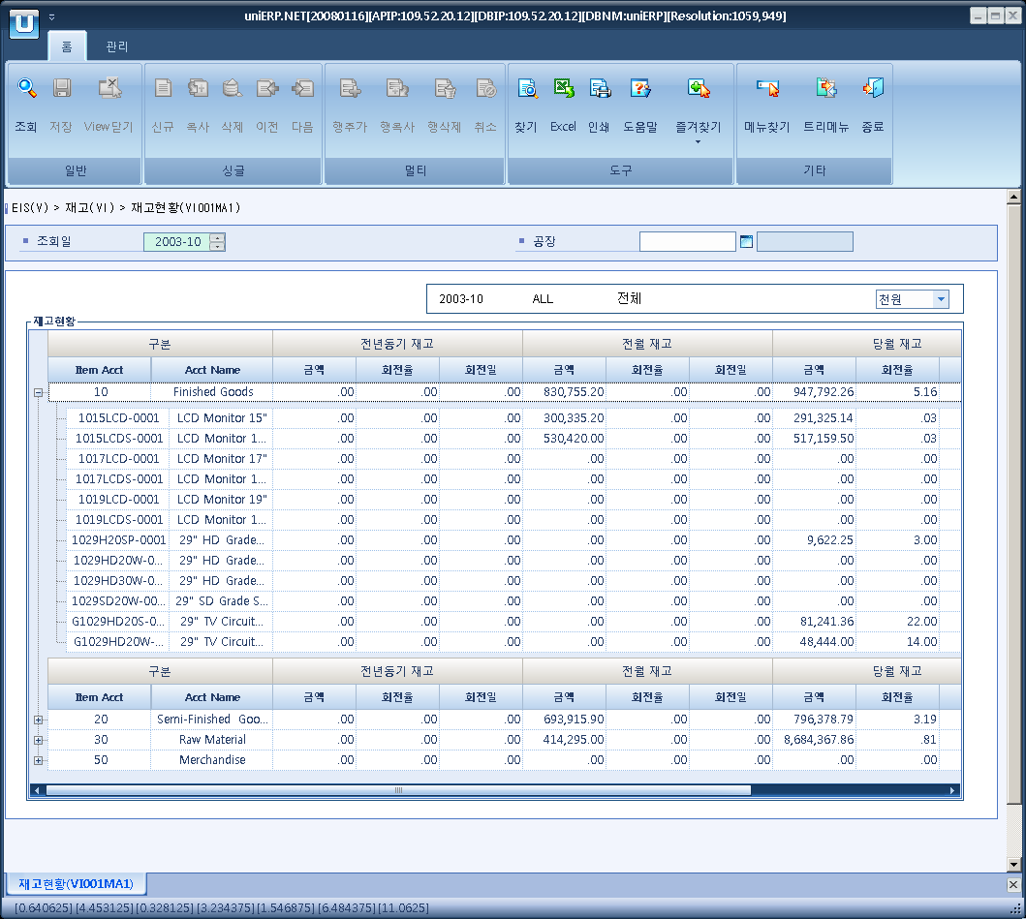

- Event flow
- Click Query button
- OnFncQuery -> DbQuery -> DataChange
- Display Unit combo change
- uniCombo1_ValueChanged -> DataChange

- SQL Statements
- The stockpile status
SELECT a.item_acct, b.minor_nm AS item_acct_nm, a.item_cd, c.item_nm,
a.pre_year_amt, a.pre_year_rate, CONVERT(DECIMAL(18, 2), a.pre_year_days) AS pre_year_days,
a.pre_month_amt, a.pre_month_rate, CONVERT(DECIMAL(18, 2), a.pre_month_days) AS pre_month_days,
a.cur_month_amt, a.cur_month_rate, CONVERT(DECIMAL(18, 2), a.cur_month_days) AS cur_month_days,
a.vs_pre_month_amt, a.vs_pre_year_amt
FROM (SELECT a.item_acct, a.item_cd,
SUM(a.pre_year_inv_amt) AS pre_year_amt,
SUM(a.pre_year_issue_amt) AS pre_year_issue_amt,
SUM(a.pre_year_sum) AS pre_year_sum,
CASE WHEN SUM(a.pre_year_sum) = 0 THEN 0
ELSE 2 * SUM(a.pre_year_issue_amt) / SUM(a.pre_year_sum)
END AS pre_year_rate,
CASE WHEN SUM(a.pre_year_issue_amt) = 0 THEN 0
ELSE 15 * SUM(a.pre_year_sum) / SUM(a.pre_year_issue_amt)
END AS pre_year_days,
SUM(a.pre_month_inv_amt) AS pre_month_amt,
SUM(a.pre_month_issue_amt) AS pre_month_issue_amt,
SUM(a.pre_month_sum) AS pre_month_sum,
CASE WHEN SUM(a.pre_month_sum) = 0 THEN 0
ELSE 2 * SUM(a.pre_month_issue_amt) / SUM(a.pre_month_sum)
END AS pre_month_rate,
CASE WHEN SUM(a.pre_month_issue_amt) = 0 THEN 0
ELSE 15 * SUM(a.pre_month_sum) / SUM(a.pre_month_issue_amt)
END AS pre_month_days,
SUM(a.cur_month_inv_amt) AS cur_month_amt,
CASE SUM(a.cur_month_sum) WHEN 0 THEN 0
ELSE 2 * SUM(a.cur_month_issue_amt) / SUM(a.cur_month_sum)
END AS cur_month_rate,
CASE WHEN SUM(a.cur_month_issue_amt) = 0 THEN 0
ELSE 15 * SUM(a.cur_month_sum) / SUM(a.cur_month_issue_amt)
END AS cur_month_days,
SUM(a.vs_pre_month_amt) AS vs_pre_month_amt,
SUM(a.vs_pre_year_amt) AS vs_pre_year_amt
FROM (SELECT a.item_acct, a.item_cd, -- 전년동월
SUM(ISNULL(b.inv_amt, 0)) AS pre_year_inv_amt,
SUM(ISNULL(b.bas_inv_amt, 0) + ISNULL(b.inv_amt, 0)) AS pre_year_sum,
SUM(ISNULL(b.issue_amt, 0)) AS pre_year_issue_amt,
0 AS pre_month_inv_amt, 0 AS pre_month_sum, 0 AS pre_month_issue_amt,
0 AS cur_month_inv_amt, 0 AS cur_month_sum, 0 AS cur_month_issue_amt,
0 AS vs_pre_month_amt,
-SUM(ISNULL(b.inv_amt, 0)) AS vs_pre_year_amt
FROM b_item_by_plant a
INNER JOIN i_monthly_inventory b
ON b.plant_cd = a.plant_cd
AND b.item_cd = a.item_cd
AND b.mnth_inv_year = CONVERT(VARCHAR(4), YEAR(DATEADD(YEAR, -1, @stryyyymm + '01')))
AND b.mnth_inv_month = SUBSTRING(CONVERT(VARCHAR(6), DATEADD(DAY, 1, @stryyyymm + '01'), 112), 5, 2)
WHERE a.plant_cd LIKE @strPlantCd
GROUP BY a.item_acct, a.item_cd

UNION ALL
SELECT a.item_acct, a.item_cd, -- 전월
0,0,0,
SUM(ISNULL(b.inv_amt, 0)),
SUM(ISNULL(b.bas_inv_amt, 0) + ISNULL(b.inv_amt, 0)),
SUM(ISNULL(b.issue_amt, 0)),
0,0,0,
-SUM(ISNULL(b.inv_amt, 0)), 0
FROM b_item_by_plant a
INNER JOIN i_monthly_inventory b
ON b.plant_cd = a.plant_cd
AND b.item_cd = a.item_cd
AND b.mnth_inv_year = CONVERT(VARCHAR(4), YEAR(DATEADD(MONTH, -1, @stryyyymm + '01')))
AND b.mnth_inv_month = SUBSTRING(CONVERT(VARCHAR(6), DATEADD(MONTH, -1, @stryyyymm + '01'), 112), 5, 2)
WHERE a.plant_cd LIKE @strPlantCd
GROUP BY a.item_acct, a.item_cd
UNION ALL
SELECT a.item_acct, a.item_cd, -- 당월
0,0,0,0,0,0,
SUM(ISNULL(b.inv_amt, 0)),
SUM(ISNULL(b.bas_inv_amt, 0) + ISNULL(b.inv_amt, 0)),
SUM(ISNULL(b.issue_amt, 0)),
SUM(ISNULL(b.inv_amt, 0)), SUM(ISNULL(b.inv_amt, 0))
FROM b_item_by_plant a
INNER JOIN i_monthly_inventory b
ON b.plant_cd = a.plant_cd
AND b.item_cd = a.item_cd
AND b.mnth_inv_year = SUBSTRING(@stryyyymm, 1, 4)
AND b.mnth_inv_month = SUBSTRING(@stryyyymm, 5, 2)
GROUP BY a.item_acct, a.item_cd) a
GROUP BY a.item_acct, a.item_cd WITH ROLLUP
HAVING item_acct IS NOT NULL) a
INNER JOIN b_minor b
ON b.minor_cd = a.item_acct
AND b.major_cd = 'P1001'
LEFT JOIN b_item c
ON c.item_cd = a.item_cd
ORDER BY a.item_acct, a.item_cd

